PICAP test plan

Brendan Bickford

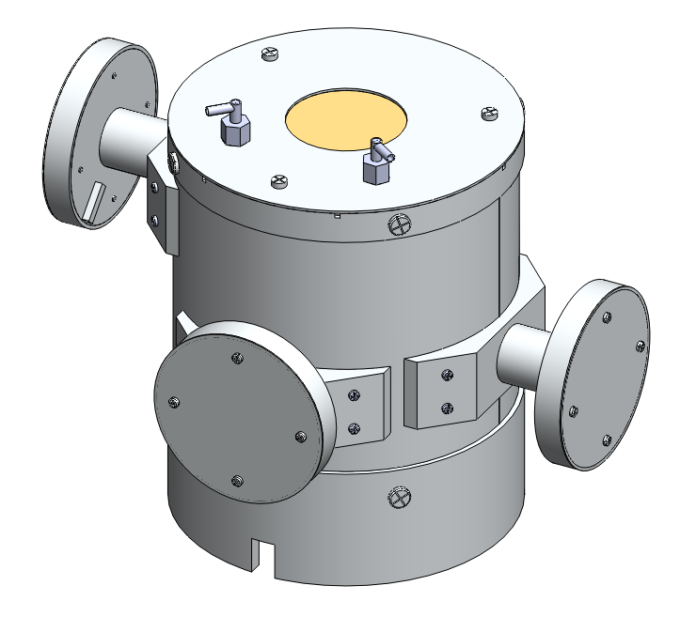

## Mechanical Design constraints

Light leaks - In order to provide efficient particle detection, ambient light outside the telescope must not be seen by any of the photomultiplier tubes.

Cross talk - When light is seen by any given scintillator, the same light should not be read by any other scintillator.

## Test procedure

For all procedures, the photomultiplier tubes and solid state detectors will be powered by a high voltage power supply. The output signal will be amplified by a pre amplifier amp into a amplifier and read by an oscilloscope and multichannel analyzer.

### Light leaks

To test for light leaks we will place the telescope in a well lit room and record the output signals. After the output signals are recorded, the lights will be shut off and a black velvet sheet will be placed over the telescope in order to block all incoming light. If the instrument is properly light proof, these signals should not significantly change.

### Cross talk

To test for cross talk between scintillators, an Alpha ray source will be culminated towards a single scintillator. If the scintillator is properly light tight, the only photomulipler tube that will produce a signal will be the one on that scinillator.